NATIONAL UNIVERSITY OF MODERN LANGUAGE ISLAMABAD
Lab 04


Submitted to:
Ms. Saadia Shabbir
Submitted by:
Zulqarnain Hassan (SP21379)
Ehsan Mehmood (SP21371)
Subject: …………………… Web engineering
Department: ……………… BSSE-5-Afternoon
Date: ……………………… 20-10-2024

Task 01
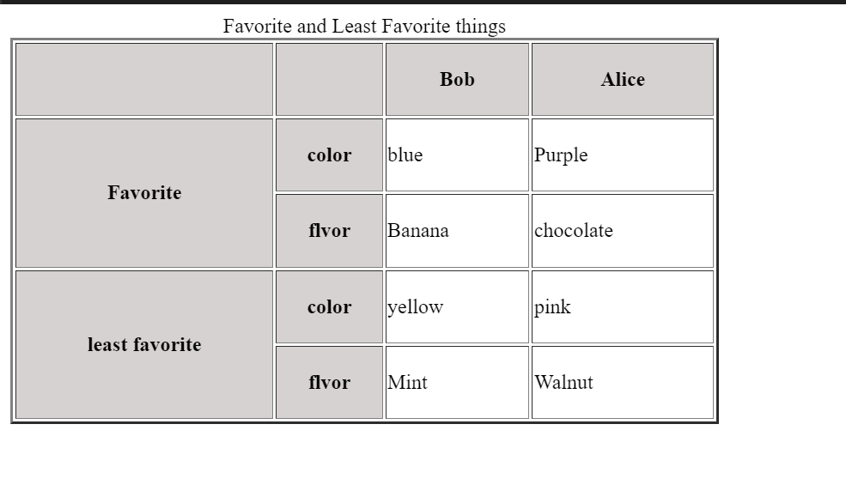
Task 02
Q2 Create a Cv using table and lists and all controls learned so far.
